**Newsletter August 2022**

**Novice Pairs Event**

**Australian Bridge Championship**

**Lyn Keeley**

Tuesday 5th July dawned with a freezing frost. Mister sun was peeping through as well though, the promise of a perfect day to come! How right he was.

Surely there could not be a better way to enjoy a cold winter’s morning than being cosy and warm, with fierce competitors, enjoying the game that we have all become addicted to!

Club members with less than 30 championship points were invited to enter the Australian Bridge Championship in a special competition. Members from the Beaumont Bridge Club attended as well.

The venue, ‘The Junction,’ Morphettville, was organised by Barbara Travis, president of the SA Bridge Federation, and our Julie Clark. The entire session ran like clockwork and their fantastic efforts were greatly appreciated by all.

At 0930 the room fell silent, butterflies settled and play commenced.

A total of 25 boards were played and friendship, concentration and competitiveness were the order of the day. No time for a break, but Julie kindly provided coffee to those requiring sustenance.

Play ceased at 12:30, and the winners announced. How thrilled and proud were we to watch Yvonne and John, Carmel and Pam select their prizes. Warmest congratulations to the Beaumont winners too. Sorry cannot recall their names.

Following that we adjourned to the dining area where we relaxed over a glass or two, and a yummy pub lunch.

We were not shy either in giving ourselves a pat on the back for being brave enough to enter the competition!

A big thank you to the Glenelg Bridge Club for generously subsidising our entry fee for the day, too.

Would we do it again? You bet, with bells on.

Our successful pairs:

Carmel and Pam Yvonne and John

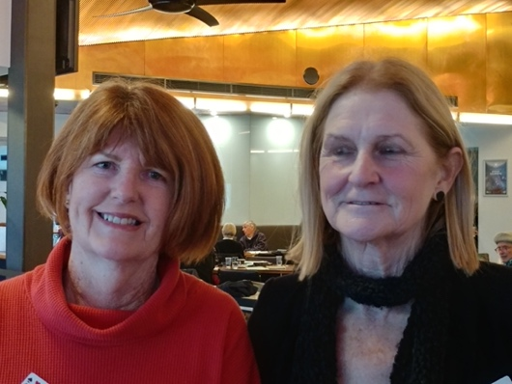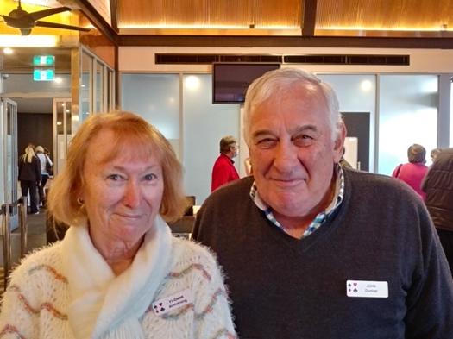

Our dedicated committee member, Jack Chyer, proudly shows his latest project. He planned and constructed our two new afternoon tea items dispensers. Thank you and well done, Jack!

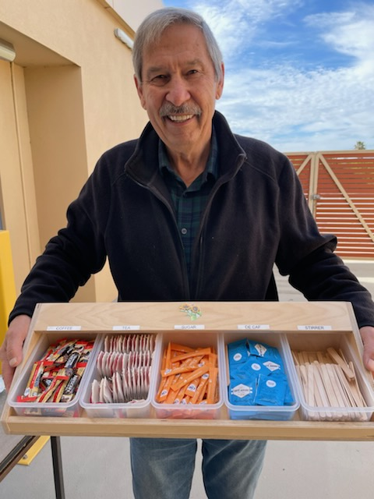

**Social Sunday**

**Getting Back Together Again**

**Jon Parrington**

That was the theme of the recently successful ‘Social Sunday’ held on the last day of July at the club.

More than 74 players attended our first ‘Social Sunday’ at the club since the start of the dreaded Covid 19 pandemic. A total of 18 1/2 tables were used in two sections under Director Arthur Porter’s watchful eye.

President Graeme Hammond was delighted with the big turnout.

“This was all about getting our members together on a social occasion so they could have time to enjoy each other’s company,” he said.

“That socialisation suffered during Covid, but it had to so that we could keep everyone as safe as possible.

“While it’s been great to keep playing, we had to put strict health measures in place to protect everyone which cut down the social side of things that we enjoyed in the past.

“As everyone knows we had to abandon the normal tea breaks, and then breaks altogether. Now we are trying to get back closer to normal and this is a good start.”

Apart from re-introducing tea and coffee back to sessions, this was also a way for members who play during different days and nights to meet each other for the first time. That worked a treat. It was also a chance for old friends, who had not returned to their full playing schedule yet, to get together.

And the icing on the cake was provided by our dedicated catering team who prepared a sumptuous afternoon tea in individual boxes which were enjoyed by everyone. The team worked extremely hard making their specialties and had a great time with each other putting the boxes together just before the event kicked off.

“They are our unsung heroes who put in an enormous amount of time to make sure we have a very special afternoon tea that works seamlessly,” Graeme said.

Of course, the winners played well and were rewarded for it with a well-deserved prize. The winners for the two sections of North/South were Julie Clark and Neil Welch and Claire Geller and Antonina Hayles. East/West’s winners were Nes Fernandez and Sue Martin and Charmaine Miller and Julie Roberts.

And next year… it’s likely to all happen again, something to look forward to so keep an eye out for it!

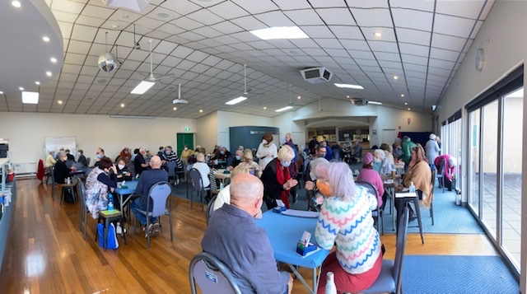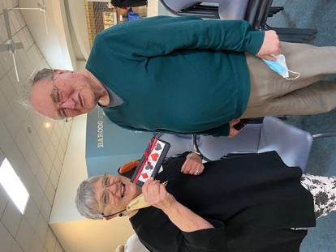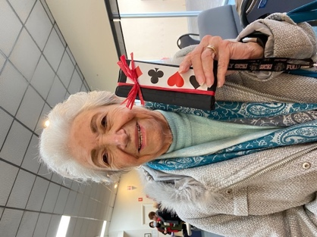

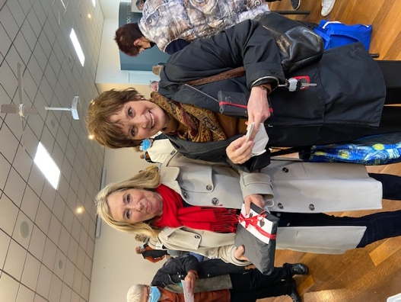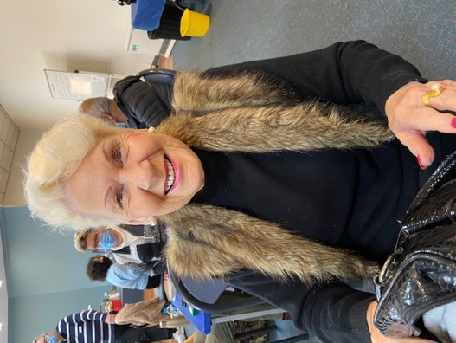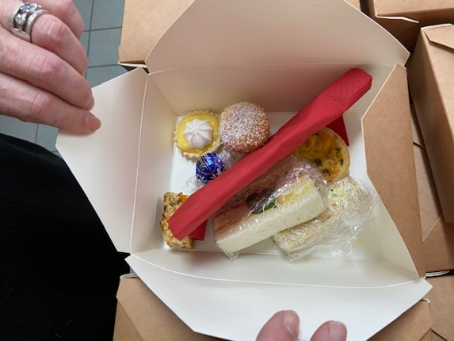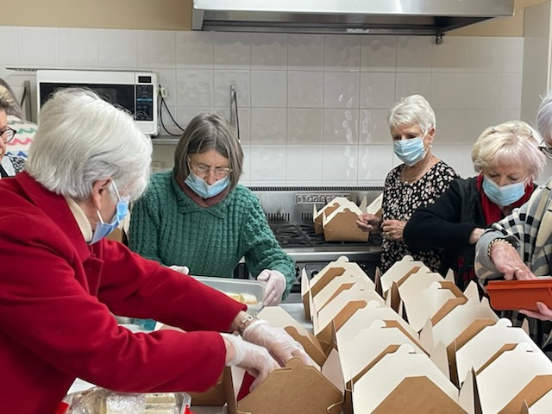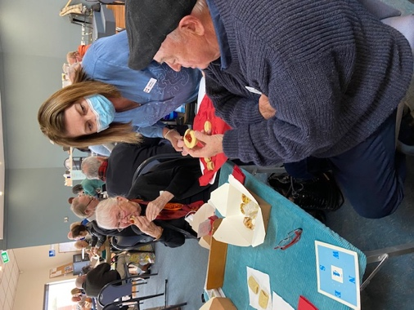

Photos: Mary Kembrey

**SABF Quiz Night**

The SABF Quiz Night is to fundraise for Youth bridge players in South Australia.  The funds are used to help our Under 25 players when they attend national bridge events interstate, when they represent South Australia or when they represent Australia (overseas).  This year, four of our youth players are in the two Australian teams that are heading to Italy for the world championships in August.  Whilst the ABF does subsidise their trip, the subsidy only covers the equivalent of their airfares, so the SABF has contributed a more substantial amount (than usual) this year to ensure those four (of the eight going) have the airfares, accommodation and living costs covered.  (I've never quite understood why the ABF is not MORE generous to the younger players, who are usually less financially secure.)  So, this Quiz Night will help replenish our funds for the next few years, when we are likely to have several younger players doing Australia proud!

Get a team together and have a fun night!



**Volunteers**

After a recent email asking for Club members to help out generally and at sessions there has been an excellent response, headed by our catering team and the library volunteers. The committee thanks everyone for their help and urge you all to continue to chip in at your sessions when you see that help is required. Now that we are having morning and afternoon tea there is an ongoing need for general clean up and tidying.