Newsletter February 2023

2022 President’s Report
Taking our cue from governments and societies around the world, the Glenelg Bridge Club spent most of 2022 gradually removing the shackles of covid restrictions. I’m not suggesting it’s over as there seem to be a large number of cases reported constantly but it seems, as predicted, we are learning to live with it. Don’t forget we were closed for all of January due to what was hopefully our last lockdown. Since then, the club has bounced back again and had a very busy year. This was in part because of Bill Jensen’s know-how and enthusiasm in taking on all the Australia-wide competitions available to clubs. His ability to liaise with the convenor, produce all the boards and send in the results led to 4 successful events, three Australia-wide and one state-wide. The Australia-wide Novice Pairs event in May gave our least experienced players a chance to participate in a large competitive session for the first time. Glenelg’s best pairs, nationwide, were: 40th - Frank Stroud & Grant Sharples and 46th - John Sharpe & Ann Seale. Congratulations to those pairs! This led to a large number of Glenelg pairs entering the ANC Novice Pairs in July, ensuring that this event went ahead.
How thrilled and proud were we to watch Yvonne and John, Carmel and Pam select their prizes.
In June the club GNOT teams event was well supported once again with 12 teams competing.
Late July saw a Social Sunday session introduced for those who needed to play more bridge. Apparently many of us fell into this category and the afternoon was a great success, both financially and socially.
The Australia-wide Open pairs was held on the last Monday in August and saw two Glenelg pairs finish in the top 100. Helen Mander and Tony Souter placed 52nd and Wendy Hooper and David De Bellis were close behind in 57th.
As the State Government covid restrictions continued to ease the committee decided to re-introduce urns and tea and coffee in time for our September Congress. It has been well received as the communal nature of gathering at the urn seems to add to the general social feeing at each session.
The congress was a success with a full house, which is now 20 tables. The catering team excelled again and the feedback from visitors was positive.
The Glenelg pair of Wendy Hooper and David De Bellis won the A grade section and congratulations go to them. Other place-getters were Arthur Porter and Ann Clarke, and Sue Phillips and Judith Roberts who came equal 3rd.
In September Warwick Bowden oversaw a mentoring initiative which paired supervised players with more experienced members for play in our regular sessions. This has complimented the Thursday supervised sessions which have helped our up and coming players to transition to play in the club’s other competitive sessions. In addition to this, other senior players have been generous with their time and experience to take players under their wing with immediate positive results.
In October, the Australia-wide Restricted Pairs was held with Stan Dunsby and Mary Kembrey, who came 54th , our most successful pair.
Having our catering team back in action, in addition to tea and coffee being available again, meant our Melbourne Cup Day session was back to its best with John Hayles conducting the sweeps again.
Glenelg has a large contingent of older players and the club recently purchased four comfortable armed chairs for their benefit. Not only were they well received but the club was compensated by the West Torrens Council for their purchase, thanks to our Treasurer who sought and secured a grant for the total amount.
Our Christmas session was held on a Friday this year and, with 19 tables playing, the catering team ensured we finished the year on a successful note.
I must pay tribute to all those members who have pitched in this year. The directors, committee and executive have been a pleasure to work with and I thank those members who are not seeking to continue, Robby Randall and Peter Teubner for their contribution. Special thanks must go to our outgoing treasurer, Gillian Gordon, who has kept a meticulous set of books, and has always maintained a sense of humour and good grace for each one of those 8 years. She has also maintained a good relationship with Tony Hughes, our auditor for many years. I also wish to thank Tony for his service to the club.
Finally, I must thank all our members who continue to play regularly and support the club and those who cheerfully volunteer their services to assist in the daily running of the club : catering group, library (purchasing, cataloguing and monitoring), tablecloths (both making and washing), purchasing for the club, tea and coffee setup, emptying bins, newsletter, mentoring and the list goes on.

Graeme Hammond
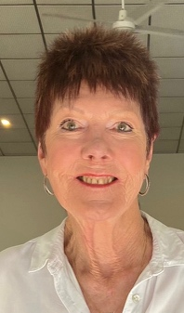
Introducing your new committee for 2023
The Executive: President: Graeme Hammond, Vice President: Julie Clark,
Secretary: Helen Wetherell, Treasurer: Julie Butler

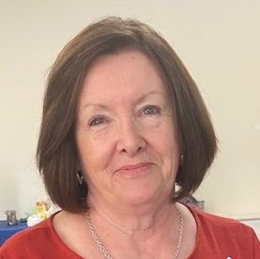
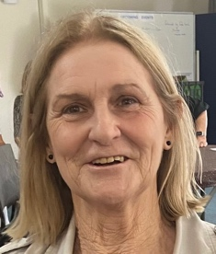
Committee Members: Continuing: Anne Stimson, Warwick Bowden, Bill Jensen, Jack Chyer,
Newly elected: Pam Murphy, Di Harvey

SABF delegate: Patricia Sharpe
Patron: Stephen Patterson to be continue as Patron
Auditor: To Be Confirmed

If any club member would like to raise an issue at a committee meeting, please approach anyone on the committee and they will ensure that your matter is raised at the next available meeting. It is also recommended that you put in writing any issue you want raised. We wish to acknowledge retiring committee members and thank them for their efforts and continuing contribution to the successful running of our club.

Congratulations! The following award winners were announced at the AGM:
The Kevin Clapp Trophy
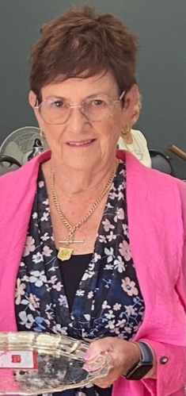
Presentation of the Kevin Clapp Memorial Trophy awarded by Presidential decision for outstanding service to the Club – Patricia Sharpe
This year there have been many members taking on roles and tasks around the club. This includes committee members, teachers and office holders who have contributed to the club beyond that which could be expected. I thank all those members but this year’s winner has made herself available to do a task that most people would find less than appealing. Patricia Sharpe has taken on the role of the club’s SABF representative and, more recently, has been liaising with the club while working on the SABF strategic planning committee. It is behind the scenes work that is important for the club and for bridge.

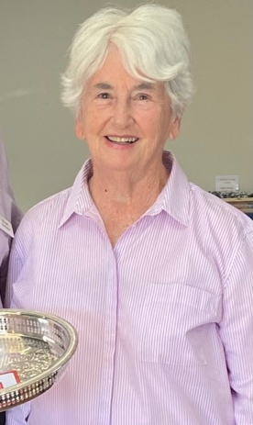

K.T. Berry Trophy is awarded annually to the Club member who has earned the greatest number of master points at the start of the year (consistent with ABF guidelines) within the Glenelg Club and representing the Club at National events during the past year.
Awarded to Judy Maloney.
This trophy is a club institution and Judy Maloney winning it is now becoming a club institution.

Wally Wood Award is awarded to a club member who had less than 5 master points at the beginning of the year and who earned the most master points during that past year. This is to encourage players within the club who are new to Bridge competition.
Awarded to Voytek Wielgosch
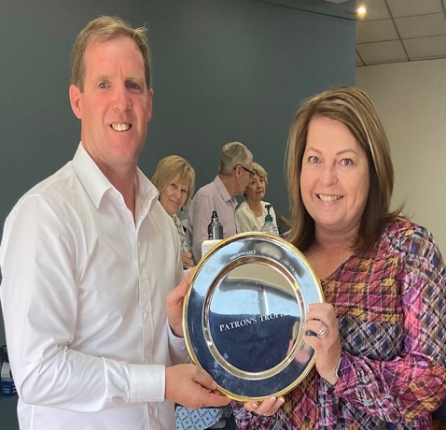

Patron’s Trophy is awarded to the member with the ranking of Regional or less at the beginning of the year, who earned the most master points during the past year.
Awarded to Andrea Dayman.
Many thanks to Stephen Patterson’s office, our club Patron for continuing support and for providing the printed versions of our newsletter.

Congratulations to all award winners!

Sponsorship from the West Torrens Council Equipment Grant
Once again, the Committee successfully applied for an equipment grant from the West Torrens Council to fund the purchase of four chairs with arms. $673.20 was received from the Council. The West Torrens Council with its aim of building stronger communities has supported our Club with equipment grants since 2016.
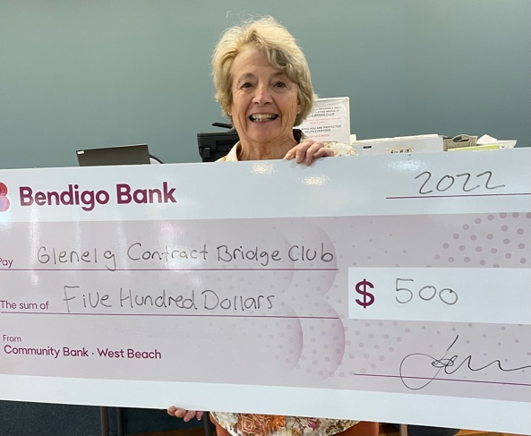
Sponsorship from the West Beach Community Bank- a Bendigo Bank
The West Beach Community Bank has also supported our Club by sponsoring our AGM for the last seven years. The bank has contributed $500 towards the cost of running our 2023 AGM. The 5-cent fundraising initiative has now finished but the bank honoured the coins we had collected and paid the club $83.80. Please consider using this bank, a five-minute drive from the Club on Burbridge Road, if you want personalized service and a Manager who is always accessible.

We thank both organizations for supporting our Club.

Gillian Gordon

Subscriptions
Membership fees are due between now and March 31st.
The fees are $40 for home members and $25 for associate members (i.e. you are a home member at another club).
We are asking all new members to fill in a membership application form and present members to please fill in a membership renewal form each year so that we can update our records.
You can pay the director or supervisor of the day when you hand in your completed membership/renewal form.

Library News
Another great year for the Library seeing our Library grow to 162 books! Quite a collection , with an additional 9 new books added late last year. Many thanks to all those who have kindly donated books which comprise almost a third of our total Library. A staggering 244 books were borrowed last year. An amazing amount of reading from our members, which makes having and maintaining the Library so worthwhile. Keep reading and learning!

Joy Giles and Julie Roberts

Dear President
I felt honoured to be presented the “Kevin Clapp Memorial Trophy” at the Annual General Meeting on Sunday February 12th, 2023.

It is a privilege to represent Glenelg on the SA Bridge Federation committee (SABF) whose role is as the governing body for bridge in SA and also a member of the Australian Bridge Federation (ABF)

The Glenelg Club Committee is recognised in these forums as a respected community club, with contributions from many members who volunteer their time over a range of tasks. I enjoy representing our club in this forum and ensuring our voice is heard. Glenelg is a happy social club at the same time promoting competitive competition.

Well done to all members of the Glenelg Bridge Club and thank you for the award.

Patricia Sharpe
Glenelg Bridge Club Delegate to the SABF

Happy event
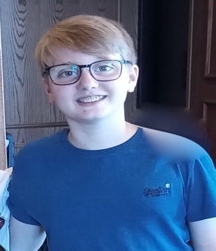
In the last week of bridge at the club last year, something new and lovely happened. Ceda Nikolic brought his grandson, Thomas, as his partner to the Wednesday session. Thomas is only 13 years old from England and was visiting his relatives in his holidays. He has been learning bridge at school for about 18 months and was keen to test out his skills with his grandfather. Everyone was so welcoming and kind to Thomas, who admitted he was a little nervous at the start. He didn’t need to be as Ceda and Thomas went on to come 2nd N-S at the end of the day. Thomas’s comment after Ceda said to him that 2nd was good, was “I wanted to come first”. Ceda’s competitive spirit clearly continues in Thomas.
Where the future looks uncertain for bridge clubs, perhaps we can foster a love of cards by playing any card game with the younger generation.

The Benefits of Playing Bridge by ChatGPT This article is written by AI - Artificial Intelligence
Bridge is a popular card game that has been enjoyed by people of all ages for many years. It is a challenging and strategic game that requires the plyers to use their mental skills to outwit their opponents. In this article, we will explore some of the benefits of playing bridge.
One of the main benefits of playing bridge is that it can improve mental agility and cognitive function. The game requires players to constantly think ahead and make strategic decisions, which helps to exercise the brain and improve problem-solving skills. Studies have shown that regular participation in activities like bridge can help reduce the risk of cognitive decline and improve overall brain health.
In addition to its cognitive benefits, bridge is also a social game that promotes social interaction and communication. It is often played in a group setting, which provides an opportunity for players to interact with others and make new friends. Playing bridge can also improve communication skills, as players must effectively communicate with their partners and opponents in order to strategize and make the best moves.
Another benefit of playing bridge is that it can reduce stress and improve mental wellbeing. The game requires concentration and focus, which can help to distract the mind from the daily stressors and provide a sense of relaxation and enjoyment. Participating in a hobby like bridge can also provide a sense of accomplishment and boost self-esteem.
Finally, bridge is a game that can be enjoyed by people of all ages and skill levels. It is a versatile game that can be played in a casual setting with friends and family, or in a competitive environment at tournaments. This makes it an accessible and enjoyable activity for people of all ages.
In conclusion, playing the card game bridge offers a range of benefits, including improved mental agility, social interaction, stress reduction and enjoyment. Whether you are a seasoned player or new to the game, bridge is a worthwhile activity that can provide numerous benefits for the mind and body.

