Newsletter November 2022

We have been very busy at the club during the last few months with no less than 6 events being held and enjoyed by our club members and players from other clubs.
The first of these was the Australia Wide Pairs held on Monday 29th August. It was very well supported and we had 16 tables which were divided into 2 sections. Bill Jensen was our director who liaised with Brad Coles who is the coordinator of the nation-wide events.
The pairs for our club who came in the top 100 were Tony Souter and Helen Mander, and Wendy Hooper and David De Bellis.
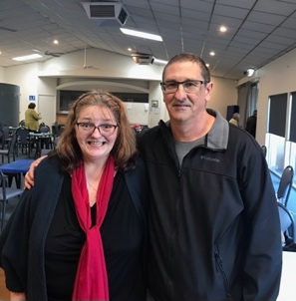
The next event was the Glenelg Congress on Saturday 3rd September. This is always a very popular event as very few other clubs provide lunch, and such a wonderful lunch it was, delivered to tables by our dedicated catering team.
Wendy Hooper and David De Bellis came 1st in this event.

Other place-getters were Arthur Porter and Ann Clarke, and Sue Phillips and Judith Roberts who came equal 3rd.
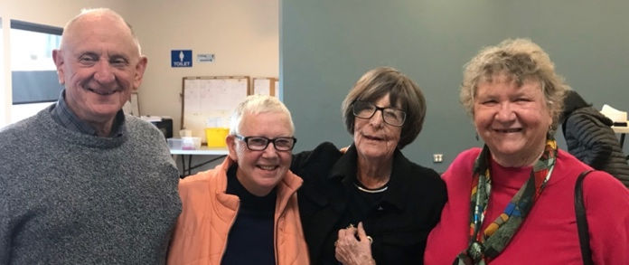

Australia Wide Restricted Pairs (less than 300 mps) was held on Thursday 27th October, with 13 tables played in 2 sections.
Congratulations to all participants and thank you for taking part and making the afternoon so enjoyable. The overall successful pairs were Stan Dunsby and Mary Kembrey who came 54th , Warwick Bowden and Jack Chyer, 90th and Chris Colmer and Ann Seale who were 120th. 14 of our pairs scored over 50% which was fantastic.

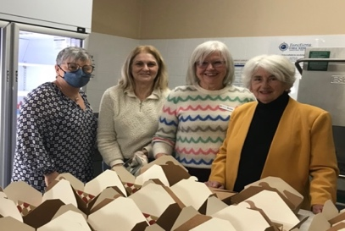
Melbourne Cup - Tuesday 1st November

Our wonderful volunteers working on afternoon tea

Melbourne Cup Day was once again celebrated at the club in style, with sweeps being organised by John Hayles, our club catering members organising a yummy afternoon tea and the session being directed by Antonina Hayles. A big thank you to all of those people who make the day so successful and enjoyable. We had 15.5 tables and 2 sections. Best dressed was won by Patricia McGaffin and best hat by Jen Clarke, congratulations!
State Wide Pairs Event Novice Session Thursday 10th November 2022
And so, we joined with part of our Bridge family, that would be the part with less than 50 masterpoints, for the big day on our own home turf.
Something especially nice about playing at home, familiar faces and surroundings make for a calming, pleasant reassurance. The president Graeme Hammond warmly welcomed everyone, explained the competition, and the well organised day got under way.
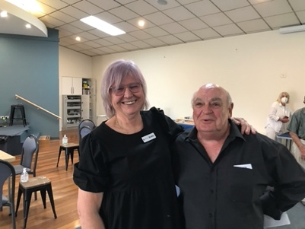
Not a huge attendance, seven tables in all. Covid being especially active may have contributed to this. A total of 28 boards were played. Those participating enjoyed a day of companionship, fun and spirited competition.
Warm congratulations to the winners:
North/South: equal winners Robby Randall/Bob Williams and Georges Baume/Marvin Bunting, 3rd Jen Clarke/ Helena Saj-Rynes
East/West: 1st Andrea Dayman/Voytek Wielgosch, 2nd Grant Sharples/Frank Stroud,3rd Michael Davidson/Heather Fels
Fabulous at the end of the day to receive the complimentary South Australian Bridge Federation Inc booklet, containing information on how the boards coulda, woulda, shoulda, been played!
Looking forward to next time!
By Lyn Keeley
State Wide Open Pairs– Friday 11th November
Again there was a good roll up for this session with 2 sections of Red: 5 and Green: 6.5 tables, directed by Arthur Porter. The winners were:
Red Section: 1st Nes Fernandez & Sue Martin, n-s and Wendy Hooper & David DeBellis, e-w;
Green Section: Arthur Porter & Ella Lupul 1st, Suzanne King & Judy Stafford 2nd
Many thanks to all who participated.

News Flash: Final overall results from the State-wide pairs.
Major winners from Glenelg Bridge Club David De Bellis came 3rd in the Open Section and in the Novice Section, 1st Andrea Dayman and Voytek Wielgosch and equal 2nd Robby Randal & Bob Williams and Georges Baume & Marvin Bunting. Congratulations!!
Member Profile – Colleen Searle
Meet one of our several dedicated and talented teachers. She is the lady with the bubbly personality and is a thoroughly conscientious and very experienced educator - Colleen Searle.
Colleen was born at Riverton on her sister’s 6th birthday, lived at Saddleworth and attended the local primary school. It was a pleasant life growing up in the rural environment.
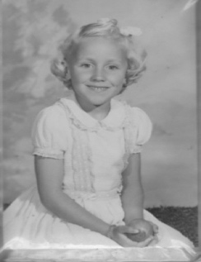
Sickness in the family caused Colleen at the age of 7 to live on her uncle’s farm at Bute on and off for 12 months. During this period, she lived with her aging Grandma and three of her offspring all unmarried: 2 uncles and an aunt all in their thirties.
Farm life was enjoyable but different for Colleen with a 32-volt generator, party line telephone, toilet down the back amongst the pepper trees. They were very aware of water conservation. The farm was almost self-sufficient with milked cows, free range eggs from the hens, geese, their own meat usually hogget, home grown vegetables and lots of fruit trees. She attended Bute primary school for 12 months, catching the school bus which went past the farm.
Following the death of her father the family moved to Woodville. Colleen’s mother needed to find work to support the family. A new life began with Colleen attending Challa Gardens Primary School in year 4. The size of the school and living in suburbia was quite overwhelming for the young Colleen. Every holiday would see her back at Bute or sometimes Karoonda on an Auntie’s farm. Even though at a young age she was travelling on her own she enjoyed the adventure of travelling by train.
Colleen enjoyed her studies at Woodville High School, especially Maths and Science. Most girls left at the end of year 10 but Colleen felt privileged to complete her Leaving Honours. She learnt the piano for 6 years, taking an exam annually in both practical and theory. Winning a scholarship to teacher’s college enabled Colleen to attend the University of Adelaide and she graduated with a Science Degree (majoring in Mathematics) and a Diploma of Education.
After university Colleen was married to Peter and this most probably allowed her to avoid being sent to the country. Her first teaching appointment was Kidman Park Technical High School for 3 years and then a year at Nailsworth Technical High School. She resigned at the end of 1973 to have a family. Two girls, born in 1974 and 1976. In 1983 the family moved to Murray Bridge and Colleen was lucky enough to receive a position at Murray Bridge High School and by the next year was back on the permanent staff. During her time at Murray Bridge High School, she was involved in the Outdoor Education Program where each year she went backpacking for 3 days in the Coorong and 5 days in the Flinders Ranges. In 1992, the family returned to Adelaide and Colleen spent the next 16 years at Brighton Secondary School. Most of Colleen’s career involved teaching all types of Maths classes from year 8 to Specialist Maths at year 12. She retired in 2007.
Well, I am not sure that we could say RETIRED. Within 2 years 5 grandchildren joined the family and the 6th 2 years later. In the true Colleen way, she has been actively involved with the care and raising of the grandchildren, enjoying watching their many sports and extra curricula activities.
In 2008 Colleen and a group of friends found out that Glenelg Bridge club were teaching lessons to beginners. They attended classes with Peter Williams as the teacher and repeated the beginners’ course to get a clearer understanding of the basics, this time with Marie McMahon. Colleen and friends progressed to supervised bridge where they stayed for quite a few years and eventually playing competition. Colleen spent two years on the committee in 2012 and 2013 as a representative of the supervised group.
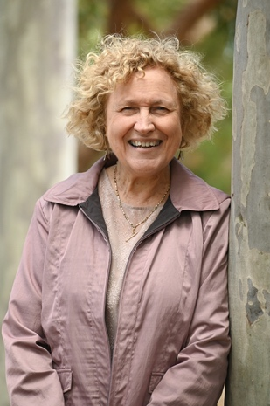
In 2020 Colleen was asked to join a group of teachers who would be looking after the supervised bridge on Tuesdays and Wednesdays. The memory of her first morning as a teacher at supervised Bridge, after a COVID lock-down, when 40 players came flowing through the door, was quite a surprise. Each supervised session includes a 10-minute Powerpoint lesson, 4 play hands on the lesson, general play and printed notes on the lesson.
Three years on Colleen and her co-teacher Julie Clark have presented many a lesson to enthusiastic and appreciative participants. It is a thriving part of the club. We thank you Colleen for the professionalism, enthusiasm, dedication and friendliness that you bring to the club.
By Helen Wetherell

Volunteers
After a recent email asking for Club members to help out generally and at sessions there has been an excellent response, headed by our catering team and the library volunteers. The committee thanks everyone for their help and urge you all to continue to chip in at your sessions when you see that help is required. Now that we are having morning and afternoon tea there is an ongoing need for general clean up and tidying.

